

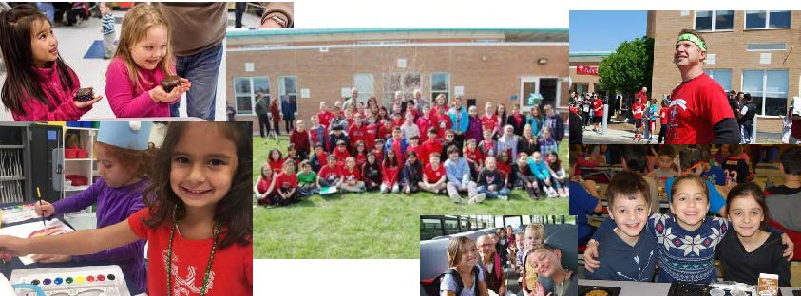



**Niles Elementary School District 71**

**Strategic Plan 2017-2020**



*. . . NURTURE, CHALLENGE, AND INSPIRE EACH STUDENT. . .*



**Background**

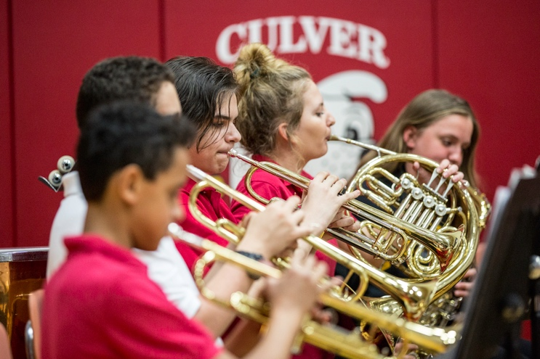

Founded in 1915, Niles Elementary School District 71 is a one-school district serving 550 students from diverse backgrounds from preschool through eighth grade. The staff of 60 teachers and support personnel at Culver School is devoted to developing the full potential of every child.

The school district is recognized statewide and nationally for its innovative instructional practices and solid educational programs.  The majority of our students score in the top levels on standardized achievement tests and meet or exceed state standards. The small size and intimacy of Culver School provides students with a unique learning experience. Small class sizes favor optimal participation, personal development, and belonging.

With the education of the individual child as the central focus, Culver School strives to provide a positive and encouraging educational climate. Each child builds a core body of knowledge, masters key skills and is supported in their social-emotional development. Students identified Culver School, “as a place where students can always find a caring adult.” This includes developing an understanding of the creative process and superior critical thinking abilities. The K-8 curriculum includes advanced programs, enrichment classes and special needs support services, all of which contribute to the development of the whole child.

The strategic planning process was designed to authentically engage stakeholders – including students, parents, teachers, administrators, staff, and community leaders – in articulating District success, values, and priorities for the future. By engaging in this process, the District developed goals, objectives, and benchmarks to move Niles School District 71 forward to better serve students and parents. This Strategic Plan presents the findings of the focus groups, individual interviews, and online survey conducted by Hazard, Young, Attea & Associates (HYA) in April 2017 for the District. The data were obtained from input the HYA consultants received when they met with individuals and groups and from the results of the online survey completed by stakeholders. The surveys, interviews, and focus group meetings were structured to gather input regarding the strengths, growth areas, and future direction of the school district to determine district priorities for the next three to five years.

**Strategic Planning Process**

The figure below is a visual representation of the strategic planning process. Each phase identifies the level of engagement involved in the development of various components of the strategic plan.

**Create a framework**

**for broad direction and priorities for the future in a formal strategic plan document.**

* Documented mission and vision, guiding principles, and the future direction desired by stakeholders.
* Developed a draft strategic plan document to serve as a broad outline to guide the future direction of the District. The strategic plan contains:
  + Mission, Vision, and Guiding Principles
  + Global Findings
  + Strategic Goals
  + Objectives
* Facilitate School Board work sessions to review research findings, goals, and objectives and finalize the strategic plan.
* Conducted 7 Board of Education structured, individual interviews.
* Conducted 13 focus groups with key stakeholder populations

(130 participants).

* Reviewed mission, vision, and guiding principles of the District.
* Reviewed archival data and reports provided by the District.
* Administered surveys of key stakeholder populations (184 respondents).

**Document the current state of reality and the desired future position of the District.**

**Document specific steps that will be taken in order to accomplish the goals and objectives identified in the strategic plan.**

**PHASE III:**

**Implement**

**PHASE I:**

**Engage**

**PHASE II:**

**Focus**

* Facilitate administrator planning meetings to guide implementation.
* Support the development of an implementation matrix, which contains the following:
  + Objectives
  + Strategies/Actions
  + Timelines
  + Responsible Persons
  + Resources
  + Metrics

The strategic planning process engaged stakeholders from the classroom to the community, providing an opportunity to learn what works well in the District and identifying areas of challenge for the future.

Three goals for the Strategic Planning Project were developed with the Superintendent and Administrative Team prior to the start of the project. They are listed below.

* + Goal 1: To validate the current plan, review and revise the goals and objectives as needed, add benchmarks, and action items.
  + Goal 2: To build consensus and support from stakeholders by conducting community engagement sessions and an online survey.
  + Goal 3: To present a new 3-5 year strategic plan to the Board of Education for adoption at the beginning of the 2017-2018 school year.

The high level of survey responses, along with the participation in the interviews and the focus groups, are strong indicators of the support that the community, parents and staff demonstrate for the school district.

The numbers of participants, by stakeholder group, in the two methods of data gathering are listed below:

|  |  |  |
| --- | --- | --- |
| **Group** | **Participants** | **Online Survey** |
| Board of Education | 7 | NA |
| Community | 16 | 2 |
| Employees | 49 | 46 |
| Parents | 35 | 136 |
| Students | 23 | NA |
| **Total** | 130 | 184 |

The “community members” group as represented above was composed of business leaders, representatives of local government, community leaders and high school administrators. School Board members were interviewed as individuals for the purpose of gathering their comments and did not convene as a group during this process.

**Common Themes**

**Strengths of the District in Alphabetical Order**

* Active parent and community support for after school extra-curricular programs
* Age appropriate academic programs at all grade levels
* Comprehensive social-emotional program
* Exciting learning environment
* Good communication with parents
* Healthy fund balances and the highest financial rating that can be awarded by the state
* High academic standards and expectations for all students
* Highly developed environment of caring for children and a sense of community in the school
* Improved collaboration, more problem solving and better communication between teachers and administrators
* Meaningful professional development for teachers and paraprofessionals
* Nationally recognized Blue Ribbon Physical Education Program
* One-to-one technology accessible to all students
* Parent and community volunteers
* Personalized learning to address individual needs of students
* Positive climate between teachers and teachers/administrators
* Safe school environment for students
* Social-emotional and academic support for all students
* Strong mathematics program focused on developing mathematical understanding
* Well-maintained facility and resources

**Common Themes (continued)**

**Growth Areas in Alphabetical Order**



* Branding the school district so that students, parents and the community feel a sense of pride in their school and are able to speak about the areas for which culver is known
* Communicating with parents representing diversity in cultures, languages, and academic expectations
* Developing common expectations regarding the rigor of the curriculum
* Expanding and increasing transition experiences to the high school.
* Grow the social emotional curriculum
* Growing current programs and implementing new programs in order to provide more opportunities and choice for all students
* Implementing an articulated and formalized set of operational processes, procedures and expectations
* Improving the accessibility of information about the curriculum, and academic expectations with parents as the target audience.
* Maintaining small class sizes
* Partnering with the high school district and other community organizations to provide more student choice

**Global Findings**

HYA based its findings upon themes that emerged from stakeholder meetings and input surveys. A major theme from every group is the strong feeling of caring for children and a sense of community that is a focal characteristic of Culver Elementary School. Teachers are supportive, caring, and engaged in the life of the school - even after school hours. The principal is well known and respected by the community and parents. Overall, there is a positive, respectful climate between teachers and teachers and administrators.

Academic programs, social-emotional expectations, and the learning environment are age appropriate and allow children to grow and learn. All students have access to technology through the District’s one-to-one laptop program. The majority of respondents on the online survey agree or strongly agree that teachers personalize learning to address the individual needs of students. Strengths of the curriculum include the Early Childhood Program, full-day Kindergarten, an inclusive special education program, the mathematics curriculum, the Fine Arts Program particularly music and art, the Enrichment Program, STEAM Program, and physical education. Overall, academic standards and expectations are high for all students.

Parents and community leaders and organizations actively support the school and its extra-curricular programs. The extra-curricular program is important to the community. All students are encouraged to become involved in extracurricular programs.



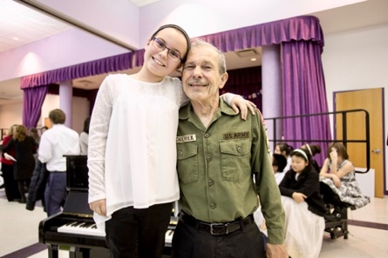



**Global Findings (continued)**

Many of the programs and characteristics that are viewed as strengths of the school district may present future challenges to the school district in terms of providing resources to maintain or grow those areas. The district has healthy fund balances and no debt. Culver class sizes are small by state and local standards. Parents and students would like students to have greater choices regarding academic subjects, foreign languages, electives, and after school programs. Maintaining small class sizes and growing programs may force the school district to consider difficult budget decisions and the use of space in the future.

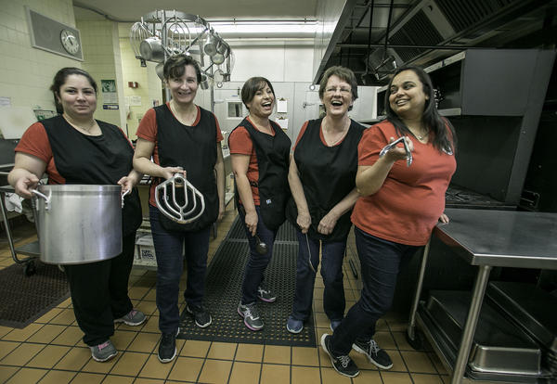The majority of the discussion in the focus groups centered on the curriculum, the delivery of instruction, and the use of technology to enhance learning. There is a discrepancy between district staff and parents regarding the rigor of the curriculum as discussed in the focus groups. District staff reported that the vast majority of students are challenged by the curriculum. Parents would like to see higher academic expectations for all students with more individualization and less emphasis on standardized tests and grades. Problem based learning and more problem solving was discussed as an option in all of the parent and community groups particularly in science and social studies.

Although school employees were given credit for being proactive in addressing discipline issues and the social emotional needs of their students, there are issues to be addressed as there would be in any

**Global Findings (continued)**

school district in the United States. The overall theme was to use disciplinary situations to teach problem solving and expectations about appropriate behavior in addition to assigning consequences for misbehavior.

Effective communication inside the district and out to the community was mentioned by nearly every focus group. Although communication was described as a strength in the district, there is a high level of passion and desire to see improvement in the quality and the quantity of communications. Parents in general want to know more about what is happening in the schools, particularly about ways to help their children academically.

Parents, community members, and students clearly articulated that Culver School is a very special place. There was a desire by all of the focus groups to compare Culver to the other schools feeding into Niles West High School. Culver has a strong rating when compared to other schools but that message is not readily apparent to the community, parents, or new families.

All of the focus groups spoke about identifying the areas in which the school excels as an important future consideration. This would allow students, parents and the community to feel a sense of pride in their school’s collective accomplishments. It would also allow the parents and community to speak about District strengths.

**District Mission and Guiding Principles**

**MISSION STATEMENT**

**A mission statement is a statement of the overall purpose of an organization.** The mission should say what you do, for whom you do it, and the benefit.

**Mission Statement**

The mission of District 71 is to provide quality learning experiences that nurture, challenge, and inspire each student to contribute to a community of excellence.

**Mission, Vision, and Guiding Principles (Continued)**

**GUIDING PRINCIPLES**

**Guiding principles are the beliefs that set the foundation for how an organization will operate.** The principles are accepted guidelines that capture the District’s values and priorities and provide direction for employees as they go about their daily work.

**Guiding Principles**

Education is the shared responsibility of students, families, the school and the community. Niles Elementary School District 71 is committed to providing each student opportunities to reach his/her full potential by:

* Fostering a safe and **nurturing** learning environment.
* Offering **challenging** programs that meet diverse physical, intellectual, social and emotional needs.
* **Inspiring** students to become self-directed learners in an ever-changing technological and multicultural world.
* Utilizing the fine arts to promote student expression and creativity.
* Respecting one another and sharing accountability for achieving the goals of the school district.

**Strategic Goals and Objectives**

The strategic goals are organized in three broad areas: Student Performance, School Identity and Accomplishments, and Maintaining a Strong Financial Position and Safe and Productive Building Facilities. The proposed objectives under each goal area are based on the themes that emerged from the focus groups and are in alignment with the District’s mission and guiding principles.

**Goal 2**

Develop and Communicate School Identity and Accomplishments

**Goal 1**

Improve Student Performance to Prepare Students for High School

**Goal 3**

Maintain a Strong Financial Position and Safe and Productive Building Facilities

**Objectives:**

3.1 Maintain long-term financial stability while continuing to improve and expand the quality of programs and opportunities for students

* Metric 3.1A: Receive the highest ISBE financial profile score and receive CAFR Award each fiscal year

3.2 Maintain a school building that facilitates instruction and supports 21st century learning standards

* Metric 3.2A: Complete all “priority” items on buildings and safety lists each fiscal year

**Objectives:**

2.1 Develop “Culver Pride” identity into school traditions and daily activities

* Metric 2.1A: Increase 5-Essential “Supportive Environment” measure to “More” level by 2020

2.2 Foster student social-emotional skills including problem solving abilities and interpersonal skills

* Metric 2.2A: Increase the Emotional Health and Grit 5-Essential Survey measure to the “More” level by 2020

**Objectives:**

* 1. Enhance the rigor of the curriculum and expectations for student performance
* Metric 1.1A: Increase the number of students receiving meets or better scores on PARCC to 60% in reading and math by 2020
* Metric 1.1B: Increase the number of students receiving a score of 5 on PARCC to 13% in reading and math by 2020
  1. Develop lessons and incorporate instructional strategies that meet International Society for Technology in Education (ISTE) standards
* Metric 1.2A: Improve all 4 elements of the Bright Bytes Survey to the highest level by 2020